PROJECT OVERVIEW
This is a lease contract analysis and fairness evaluation system that uses AI/ML technologies to extract text from lease documents, analyse their fairness, and provide negotiation guidance to customers. The project is hosted in InfosysSpringboard.

PROJECT OBJECTIVES
1. **Extract text** from lease PDF documents using OCR (Optical Character Recognition)
2. **Tokenize and chunk** text for semantic analysis
3. **Analyze contract fairness** using embeddings and LLM (Large Language Model)
4. **Identify red flags** in lease agreements
5. **Provide negotiation advice** based on contract clauses
6. **Web UI** for interactive lease processing via Streamlit

---

**TECHNICAL ARCHITECTURE**

####**Core Technologies Used:**
- **Python 3.x** - Primary programming language
- **Streamlit** - Web application framework for UI
- **PDF Processing:**
- `pytesseract` - OCR text extraction from images
- `pdf2image` - PDF to image conversion
- poppler-25.12.0 - PDF rendering library
- **Embeddings & Semantic Search:**
- `sentence-transformers` (Model: `all-MiniLM-L6-v2`) - Text vectorization
- `faiss` - Facebook AI Similarity Search for vector indexing
- **LLM Integration:**
- `ollama` with `gemma:2b` model - Local LLM for contract analysis
- **Data Processing:** `numpy`, `json`, `requests`, `re`

---

### **PROJECT STRUCTURE & FILES**

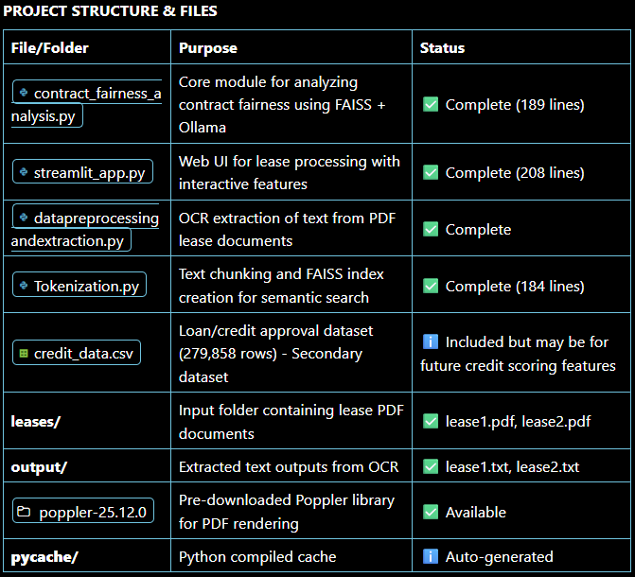
### **FUNCTIONAL MODULES & COMPONENTS**

1. PDF Preprocessing & OCR Extraction
File: datapreprocessingandextraction.py
- Converts PDF documents to images at 300 DPI
- Applies OCR using Tesseract to extract text from each page
- Outputs extracted text to `.txt` files in output folder
- Configuration: `C:\Program Files\Tesseract-OCR\tesseract.exe`

**2. Text Tokenization & Chunking**
**File:** Tokenization.py
- Loads all extracted `.txt` files from output folder
- Splits text into semantic chunks (120 words per chunk, minimum 20 words)
- Creates embeddings using `all-MiniLM-L6-v2` model
- Builds FAISS index for fast semantic similarity search
- Configuration:
- `TOP_K = 6` relevant chunks
- `MAX_CONTEXT_WORDS = 400`

**3. Contract Fairness Analysis**
**File:** contract_fairness_analysis.py
- Analyzes lease contracts for fairness using semantic search
- Queries for fairness-related keywords: *"contract fairness red flags penalties unfair terms termination fees deposits mileage insurance"*
- Calls Ollama LLM (gemma:2b) to analyze extracted clauses
- **Outputs:**
- Fairness Score (1-10 scale)
- Red Flags with severity levels (low/medium/high)
- Overall assessment summary
- Default input: lease1.txt

4. Streamlit Web Application
File: streamlit_app.py
- Three-Stage Pipeline:
1. PDF Upload & OCR Extraction - Users upload lease PDFs and extract text
2. Datapoint Extraction - Automatically extracts key datapoints:
- Fees
- Deposit details
- Mileage limits
- Excess mileage charges
- Fuel policies
3. Negotiation Advice Generator- Uses FAISS + Ollama to suggest negotiation strategies
- Session state management for workflow continuity
- JSON output formatting

---

DATA FLOW

```
User uploads Lease PDF
↓
PDF → Image Conversion (Poppler)
↓
OCR Text Extraction (Tesseract)
↓
Text saved to output/*.txt
↓
Text Chunking (120-word chunks)
↓
Embedding Generation (all-MiniLM-L6-v2)
↓
FAISS Index Creation
↓
Semantic Search (Query: fairness-related terms)
↓
Context Extraction (Top-K chunks)
↓
Ollama LLM Analysis (gemma:2b)
↓
JSON Output (Fairness Score + Red Flags)
↓
Streamlit UI Display
```

---

### **KEY FEATURES IMPLEMENTED**

✅ **OCR Text Extraction** - Converts scanned PDFs to searchable text
✅ **Semantic Search** - Uses FAISS for fast similarity matching
✅ **Contract Fairness Scoring** - AI-powered analysis of lease terms
✅ **Red Flag Detection** - Identifies unfair, risky, or hidden clauses
✅ **Negotiation Guidance** - LLM-generated negotiation strategies
✅ **Interactive Web UI** - Streamlit-based user interface
✅ **Session Management** - Maintains workflow state in Streamlit
✅ **JSON Output** - Structured, machine-readable results

---

### **CONFIGURATION DETAILS**

| Setting | Value | Purpose |
|---|---|---|
| Tesseract Path | `C:\Program Files\Tesseract-OCR\tesseract.exe` | OCR engine executable |
| Poppler Path | bin | PDF rendering |
| Embedding Model | `all-MiniLM-L6-v2` | Sentence transformer for vectorization |
| LLM Model | `gemma:2b` via Ollama | Local language model |
| LLM Endpoint | `http://localhost:11434/api/generate` | Ollama server URL |
| Top-K Results | 6 | Relevant chunks retrieved from FAISS |
| Max Context Words | 400 | Maximum words sent to LLM |
| Timeout | 600 seconds | LLM response timeout |
| DPI | 300 | PDF image resolution for OCR |

---

### **INPUT DATA**

**Lease Documents:**
- lease1.pdf - Sample lease contract 1
- lease2.pdf - Sample lease contract 2

**Extracted Text (Output):**
- lease1.txt - Extracted text from lease1.pdf
- lease2.txt - Extracted text from lease2.pdf

**Additional Dataset:**
- credit_data.csv - 279,858 loan/credit records (columns: Age, Gender, Income, Credit Score, Loan Amount, etc.)
- *Note: This appears to be auxiliary data for future credit scoring or risk assessment integration*

---

### **CURRENT STATUS**

| Component | Status | Notes |
|---|---|---|
| OCR Extraction | ✅ Complete | Text extraction from PDFs working |
| Text Chunking | ✅ Complete | Tokenization and chunking implemented |
| FAISS Indexing | ✅ Complete | Vector search infrastructure ready |
| Fairness Analysis | ✅ Complete | AI analysis pipeline functional |
| Streamlit UI | ✅ Complete | Web interface implemented |
| LLM Integration | ⚠️ Requires Setup | Ollama server must be running locally |
| Negotiation Advice | ✅ Complete | Feature implemented in Streamlit app |

---

### **DEPENDENCIES & SETUP REQUIREMENTS**

**System Requirements:**
- Windows OS (configured for C: drive paths)
- Tesseract-OCR installed (`C:\Program Files\Tesseract-OCR\`)
- Ollama installed and running (`http://localhost:11434`)
- Python 3.8+

**Python Packages:**
```
streamlit
pytesseract
pdf2image
faiss-cpu (or faiss-gpu)
sentence-transformers
numpy
requests
```

---

### **EXECUTION FLOW**

**Option 1: Batch Processing**
```
python datapreprocessingandextraction.py # Extract text from PDFs
python Tokenization.py # Create FAISS index
python contract_fairness_analysis.py # Analyze fairness
```

Option 2: Interactive Web UI
```
streamlit run streamlit_app.py # Launch web application
```

---

RECENT SESSION ACTIVITIES

Based on the code state, the following work has been completed:

1. ✅ **OCR Pipeline Setup** - PDF to text conversion pipeline established with Tesseract and Poppler
2. ✅ **Semantic Chunking** - Text divided into 120-word chunks for processing
3. ✅ **FAISS Implementation** - Vector index created for fast semantic search
4. ✅ **LLM Integration** - Ollama integration for contract analysis
5. ✅ **Fairness Analysis Engine** - Implemented scoring and red flag detection
6. ✅ **Streamlit Interface** - Interactive web app with 3-stage pipeline
7. ✅ **Datapoint Extraction** - Regex-based extraction of key lease terms
8. ✅ **Negotiation Advice Generator** - LLM-powered suggestions for lease negotiation
9. ✅ **Error Handling** - Connection handling and timeout management

